**Student Name:** Aakash Thapliyal  **UID:** 24MCC20027

**Branch:** MCA(ccd) **Section/Group:** A 1

**Semester:** 1st  **Date of Performance:** 22-10-2024

**Subject Name:** Python Programming **Subject Code:** 24CAH-606

**Q. Title of Project.** Password Generator Using Python

**Aim/Overview of the practical:** In today's digital world, ensuring secure authentication is of utmost importance. One of the primary ways to protect data is by using strong and secure passwords. This project involves creating a simple yet effective password generator using Python that generates random passwords based on a combination of lowercase letters, uppercase letters, and digits. The user is prompted to input the desired password length, and the program generates a random password accordingly.

**1. Task to be done:**The objective of this project is to develop a Python-based tool to generate random and secure passwords, enhancing the security of user accounts by providing unique and unpredictable passwords.

**2. Code for experiment/practical:**

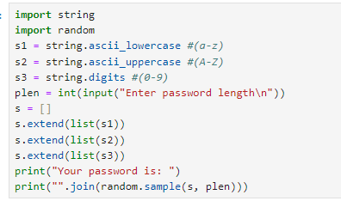

1. **Result/Output/Writing Summary:**

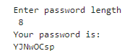

1. **Future Scope:**This project can be enhanced by:
2. Adding special characters to increase password complexity.
3. Creating a graphical user interface (GUI) for ease of use.
4. **Modules Used:**

string: To access pre-defined character sets like lowercase letters, uppercase letters, and digits.

random: To shuffle and generate a random selection of characters for the password.

1. **Conclusion:**The password generator is an efficient tool that provides users with a strong and random password, significantly reducing the chances of security breaches. This project demonstrates the importance of generating complex passwords and how Python can be effectively used to solve real-world security challenges.

**Learning outcomes (What I have learnt):**

1. **Understanding of Python Modules**: Gained proficiency in using Python’s built-in string and random modules to access character sets and generate random sequences. This provided insight into how Python can handle string manipulation and randomization.
2. **Knowledge of String Operations**: Learned how to work with string data types and perform operations such as extending lists with multiple character sets (lowercase, uppercase, digits), and joining strings to create a final password.
3. **Randomization Techniques**: Gained insight into randomization techniques by learning how to shuffle and sample elements randomly using the random.sample() function, which is essential in generating unpredictable passwords.